**Tugas Pertama**

Buatlah Desain Class Diagram yang Merepresentasikan Class-Class yang ada pada Studi Kasus Aplikasi Banking.

**Diagram Program**

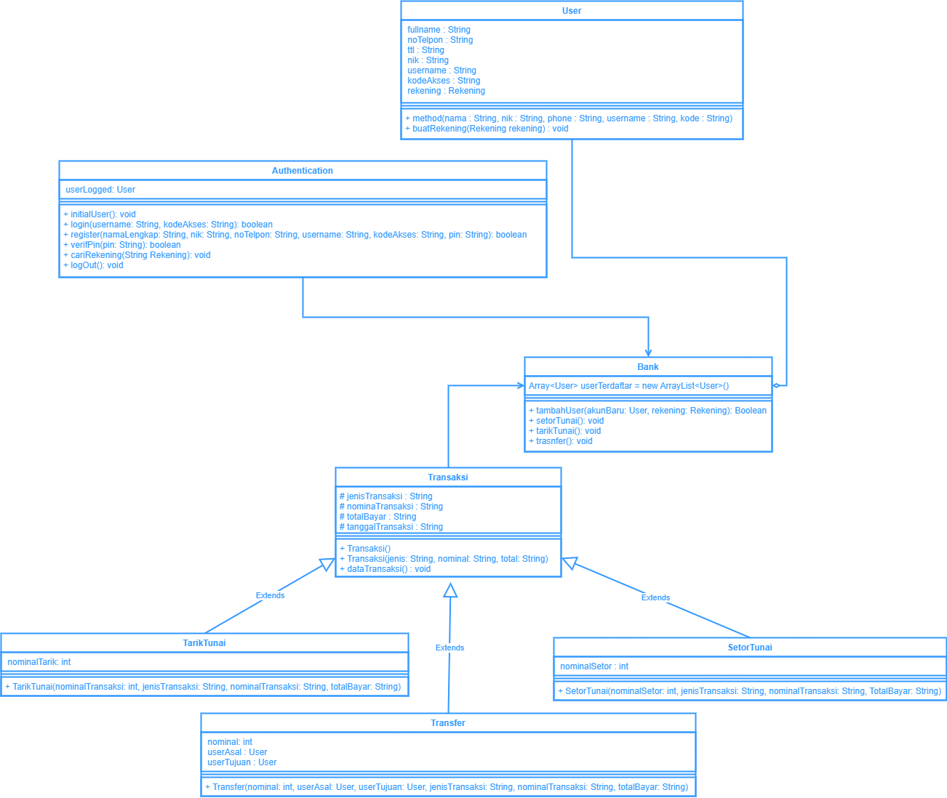

**Tugas Kedua**

Buatlah Kode Program yang menerapkan Konsep Inheritance supaya pada saat mencetak data pada setiap Class akan memiliki keluaran (output) yang berbeda-beda.

**Source Code**

Class Member.java

public class Member {

protected String nama, alamat, password;

protected int noTelepon;

public String getPassword() {

return password;

}

}

Class DataMahasiswa.java

public class DataMahasiswa extends Member {

protected int npm;

public int getNpm() {

return npm;

}

DataMahasiswa(String nama, String alamat, int noTelepon, int npm, String password) {

super.nama = nama;

super.alamat = alamat;

super.noTelepon = noTelepon;

this.npm = npm;

super.password = password;

}

public void cetak() {

System.out.println("Nama : "+super.nama);

System.out.println("Alamat : "+super.alamat);

System.out.println("No. Telepon: "+super.noTelepon);

System.out.println("NPM : "+this.npm);

System.out.println("Pass : "+super.password);

System.out.println("-----------------------------");

}

}

Class Mahasiswa.java

import java.util.ArrayList;

public class Mahasiswa{

private ArrayList<DataMahasiswa> mahasiswa;

public Mahasiswa(){

mahasiswa = new ArrayList<>();

}

private int search(int npm)

{

for (int baris = 0; baris < this.mahasiswa.size(); baris++)

{

if (npm == this.mahasiswa.get(baris).getNpm())

{

return baris;

}

}

return -1;

}

public void read()

{

System.out.println("==== DATA Mahasiswa ====");

for (DataMahasiswa value : this.mahasiswa) {

value.cetak();

}

}

public void create(String nama, String alamat, int noTelepon, int npm, String password)

{

this.mahasiswa.add(new DataMahasiswa(nama, alamat, noTelepon, npm, password));

}

public int cekLogin(int npm, String pass)

{

for (DataMahasiswa value : this.mahasiswa) {

if (npm == value.getNpm()) {

if (pass.equals(value.getPassword())) {

return value.getNpm();

}

}

}

return -1;

}

public int login(int npm, String pass)

{

int npmMahasiswa = this.cekLogin(npm,pass);

if (npmMahasiswa == -1)

{

System.out.println("NPM "+npm +" login gagal");

}

else

{

System.out.println("NPM "+npm +" login berhasil");

}

System.out.println("-----------------------------");

return npmMahasiswa;

}

public void delete(int npm)

{

int index = this.search(npm);

if (index == -1)

{

System.out.println("data tidak ditemukan");

}

else

{

this.mahasiswa.remove(index);

System.out.println("data dengan NPM "+index +" berhasil dihapus");

}

System.out.println("-----------------------------");

}

}

Class DataTutor.java

public class DataTutor extends Member {

protected int nip;

public int getNip() {

return nip;

}

DataTutor(String nama, String alamat, int noTelepon, int nip, String password) {

super.nama = nama;

super.alamat = alamat;

super.noTelepon = noTelepon;

this.nip = nip;

super.password = password;

}

public void cetak() {

System.out.println("Nama : "+super.nama);

System.out.println("Alamat : "+super.alamat);

System.out.println("No. Telepon: "+super.noTelepon);

System.out.println("NIP : "+this.nip);

System.out.println("Pass : "+super.password);

System.out.println("-----------------------------");

}

}

Class Tutor.java

import java.util.ArrayList;

public class Tutor{

private ArrayList<DataTutor> tutor;

public Tutor(){

tutor = new ArrayList<>();

}

private int search(int npm)

{

for (int baris = 0; baris < this.tutor.size(); baris++)

{

if (npm == this.tutor.get(baris).getNip())

{

return baris;

}

}

return -1;

}

public void read()

{

System.out.println("==== DATA Tutor Pendidik ====");

for (DataTutor value : this.tutor) {

value.cetak();

}

}

public void create(String nama, String alamat, int noTelepon, int nip, String password)

{

this.tutor.add(new DataTutor(nama, alamat, noTelepon, nip, password));

}

public int cekLogin(int npm, String pass)

{

for (DataTutor value : this.tutor) {

if (npm == value.getNip()) {

if (pass.equals(value.getPassword())) {

return value.getNip();

}

}

}

return -1;

}

public int login(int npm, String pass)

{

int npmMahasiswa = this.cekLogin(npm,pass);

if (npmMahasiswa == -1)

{

System.out.println("NIP "+npm +" login gagal");

}

else

{

System.out.println("NIP "+npm +" login berhasil");

}

System.out.println("-----------------------------");

return npmMahasiswa;

}

public void delete(int npm)

{

int index = this.search(npm);

if (index == -1)

{

System.out.println("data tidak ditemukan");

}

else

{

this.tutor.remove(index);

System.out.println("data dengan NIP "+index +" berhasil dihapus");

}

System.out.println("-----------------------------");

}

}

Class Kinerja.java

public class Kinerja {

public void kinerja() {

System.out.println("Tugas Asistensi Pertemuan Ke-7");

//input Data Mahasiswa

Mahasiswa mahasiswa = new Mahasiswa();

Tutor tutor = new Tutor();

mahasiswa.create("Ryan", "Raya mastrip 177", 419382948, 7467, "ryanga");

mahasiswa.create("Mutiara", "Pondok Maritim", 936301749, 9869, "mdsq");

tutor.create("Arif", "Griya taman Asri", 946292837, 1543, "rif");

tutor.create("Ferdinand", "Royal Residence", 937219275, 1653, "frdnd");

mahasiswa.read();

tutor.read();

//cek & method Delete

mahasiswa.delete(5939);

mahasiswa.delete(9869);

tutor.delete(1653);

tutor.delete(1837);

//tes login

int npm = mahasiswa.login(9869, "mdsq");

int npm1 = mahasiswa.login(7467,"ryanga");

int nip = tutor.login(1653, "frdnd");

int nip1 = tutor.login(1543, "rif");

}

}

Class Main.java

public class Main {

public static void main(String[] args) {

Kinerja kerja = new Kinerja();

kerja.kinerja();

}

}

**Output Program**

|  |
| --- |
|  |